Instructions for the preparation of papers to be presented at the 7th European Conference for Aeronautics and Space Sciences

First Author* and Second Author**

*First Author’s Affiliation

First Author’s Address

**Second Author’s Affiliation

Second Author’s Address

Abstract
This document is the layout template to be used for the 7^{h} European Conference for Aeronautics and Space Sciences which will take place in Milan, Italy, from 3 July to 6 July 2017. The easiest way to proceed is to simply insert your paper directly into this template. Please follow precisely these instructions, so that all papers have a similar presentation. The abstract should be limited to a maximum of 100 words. It must summarize the paper in an explicit way, in particular, the methods used, the main results, and the conclusions. The paper abstract and title must faithfully reflect its content.

1. Introduction
This example illustrates the paper layout and presents the various requirements that you should respect before submitting your paper. The papers will be typeset on A4 paper with top, lateral and bottom margins of 30, 22 and 25 millimeters, respectively. A single column format is to be used. The paper should be typeset in either Times or Times New Roman font, 10 point size. The section and subsection titles should be typeset according to the format and weight of the present template.

1.1 Equations
Equations must be centred and right numbered. An empty line must be inserted before and after the equation:

(1)

Be sure that the symbols in your equation are defined before or immediately following the equation or add a nomenclature.

1.2 Mathematical formulas inserted in the text
Simple fractions inserted in the text must include parentheses where needed to avoid any confusion, for example to distinguish between 1/(n − 1) et 1/n − 1. Fractions must be aligned in the text using the slash (/) symbol, except for fractions such as ½. Besides, oversized symbols must not be used.

1.3 General recommendations regarding notations
Notations must be legible, clear, compact and consistent with the usual standards. In general, acronyms should be defined when first used.
Radical signs. Oversized radical signs should be avoided whenever possible through the use of the 1/2 exponent notation. For example, replace by [(a + b)(a − c)]^{1/2}.
Exponential signs. Avoid exponential signs such as e^{jkl} . Use instead the alternative notation “exp”, e.g. exp(jkl).
Multiplications. In general, typeset multiplications as p_{y}t_{to}. Use the cross symbol × if the multiplication sign is really essential (1 × 10²) or to indicate the continuation of an equation [see Eq. (1) above]. Use the centred dot for scalar products only (k·k).
Units. Use SI units and conventions whenever appropriate. The value and the unit symbol shall be separated by a non-breaking space. Symbols for derived units formed by multiplication are joined with a centre dot (⋅) or a non-breaking space, e.g. N⋅m or N m, while symbols for derived units formed by division are joined with a solidus (/) or given as a negative exponent, e.g. m/s or m s⁻¹.
Decimal marker. The symbol for the decimal marker shall be the point on the line.
Thousands separators. Commas or periods must not be used as a thousands separator in order to reduce confusion resulting from the variation between these forms in different countries. In contrast, thin spaces should be used as a thousands separator (10 000 000) or the number of digits might be reduced using the prefixes for the SI units.

2. Figures and tables
Particular care should be observed for the preparation of diagrams and figures. Colour should be used only when it helps improve understanding. Figures must be centered. Captions must be typeset in 10 point size and the first letter must be capitalized. Please do not include captions as part of the figures and do not put captions in separate text boxes linked to the figure.

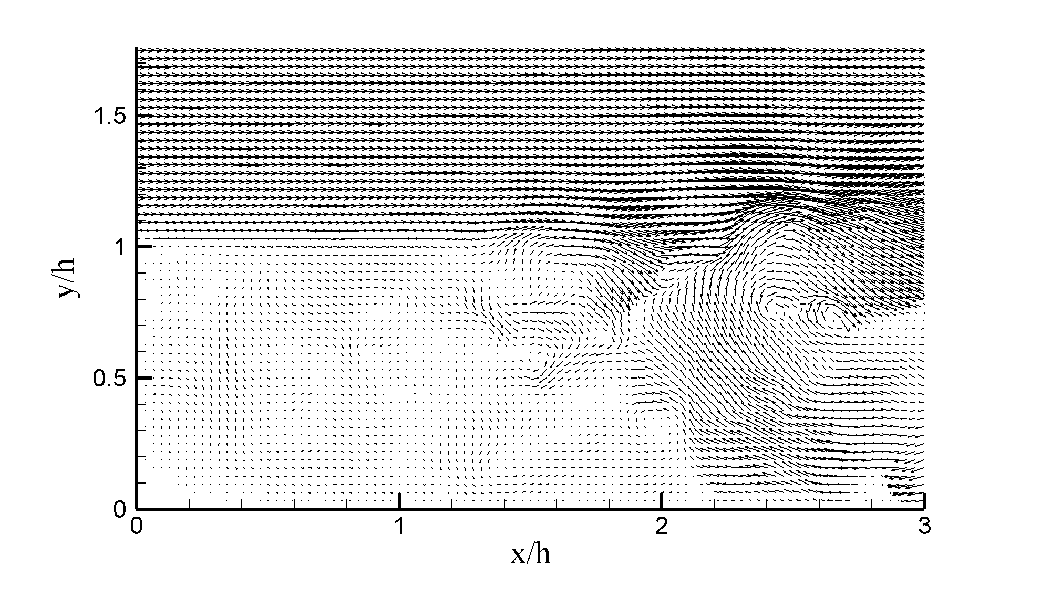
Figure 1: Example

Tables must be numbered. Table captions must be compact and positioned above the table. Detailed explanations or notes must be placed directly under the table as in the following example. Tables must include horizontal rules to clearly indicate the table limits and the column headers. In general, no other rules should be used.

Table 1: This is a table example
 | Case 1 | Case 2 | Case 3
Observation | 10 | 13 | 5
Relative frequency | 0.198ª | 0.2 | 0.1
ªRemark or comment

3. Paper length/file size
The paper should not exceed 15 pages. Please upload your file in plain portable document format (pdf) only, i.e. the file should not be protected nor in any other format. The submitted pdf file should not exceed 5 Megabytes. If your file is much larger, there is probably a figures resolution problem. This should be fixed when creating the pdf file. The editorial team will take care of protecting the paper after verification of the layout.

References
References must be numbered in the text in the following style [3] and listed at the end of the paper in the following way.

  - Degrez, G., P. Barbante, M. de la Llave, T. Magin, and O. Chazot. 2001. Determination of the catalytic properties of TPS materials in the VKI ICP facilities. In: 3rd ECCOMAS Computational Fluid Dynamics Conference. 162–167.
  - Magin, T., and G. Degrez. 2004. Transport algorithms for partially ionized and unmagnetized plasmas. J. Comput. Phys. 198:424–449.
  - AGARD. 1998. A selection of test cases for the validation of large eddy simulations of turbulent flows. Agard Advisory Report 345. North Atlantic Treaty Organization.
  - Rini, P. 2006. Analysis of differential diffusion phenomena in high enthalpy flows, with application to thermal protection material testing in ICP facilities. PhD Thesis. Université Libre de Bruxelles, Faculté des Sciences Appliquées.

